Prometheus, Alertmanager and Grafana Installation Guide

Install Prometheus
Our first task is to install Prometheus locally on our machines. To do that, you can download a pre-compiled binary from here: https://prometheus.io/download/
Extract the downloaded archive to a directory of your choice.
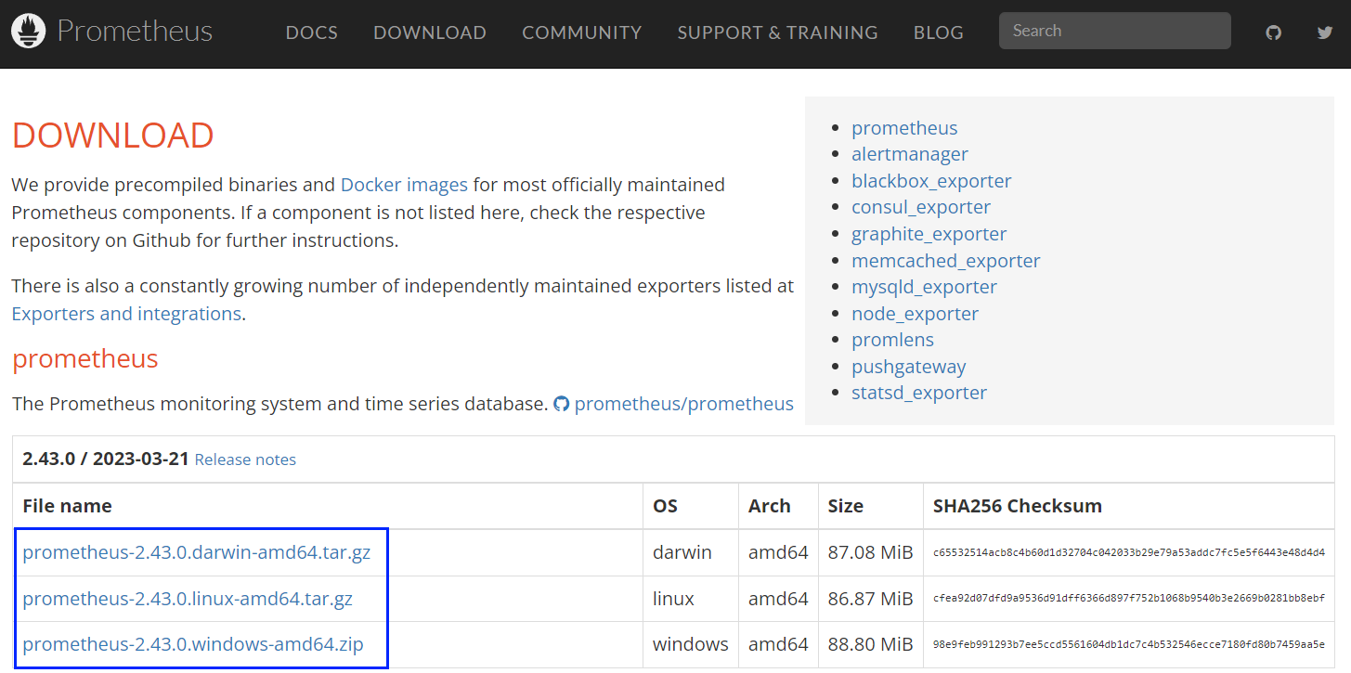
↓
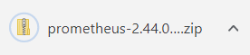
↓
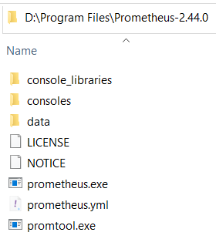
Now, navigate to the directory of the extracted archive and open the prometheus.yml file in a text editor.
This YAML file is the primary configuration file for Prometheus.
You'll need to modify it to define the targets you want to be scraped or you can create and use a new file.
This YAML file has a sample configuration in which Prometheus scrapes data from its own server:
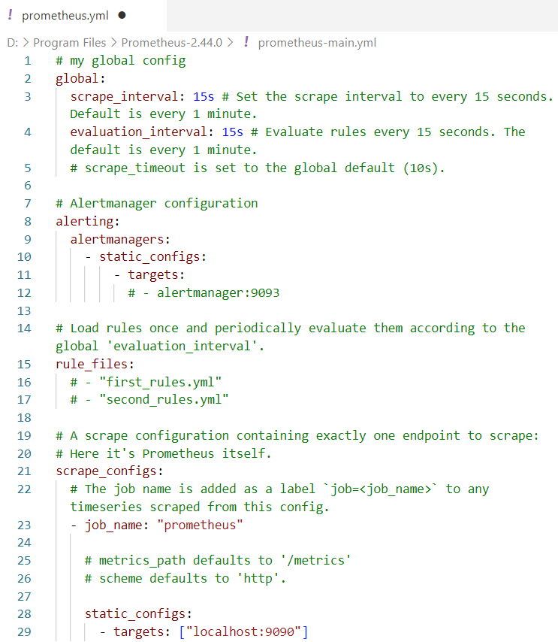

Install Alertmanager
Now, it's time to install Alertmanager. Its installation is pretty straight-forward.
Install Alertmanager using a pre-compiled binary from the same URL as Prometheus: https://prometheus.io/download/. Extract the downloaded archive to a directory of your choice
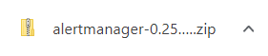
↓
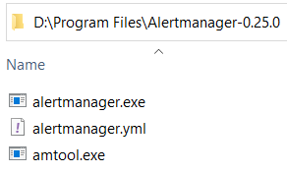
↓
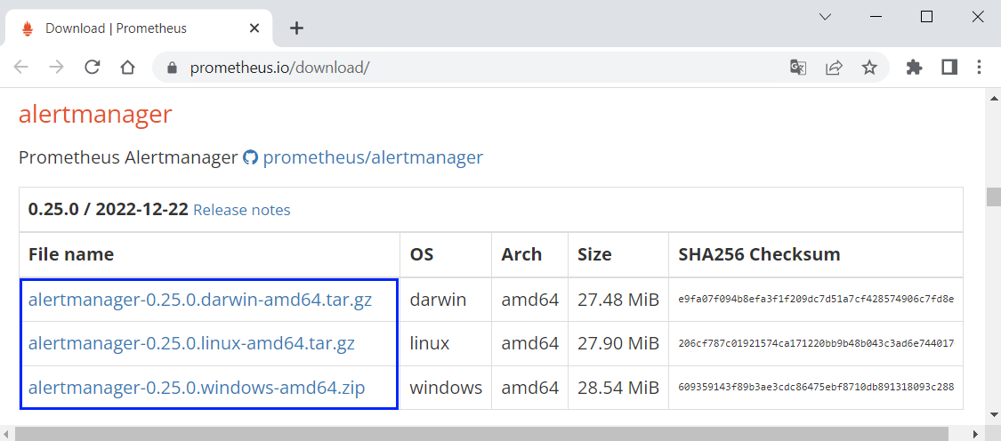

Install Grafana
Let's install Grafana. In order to do so, download an installer from here: https://grafana.com/grafana/download?platform=windows:
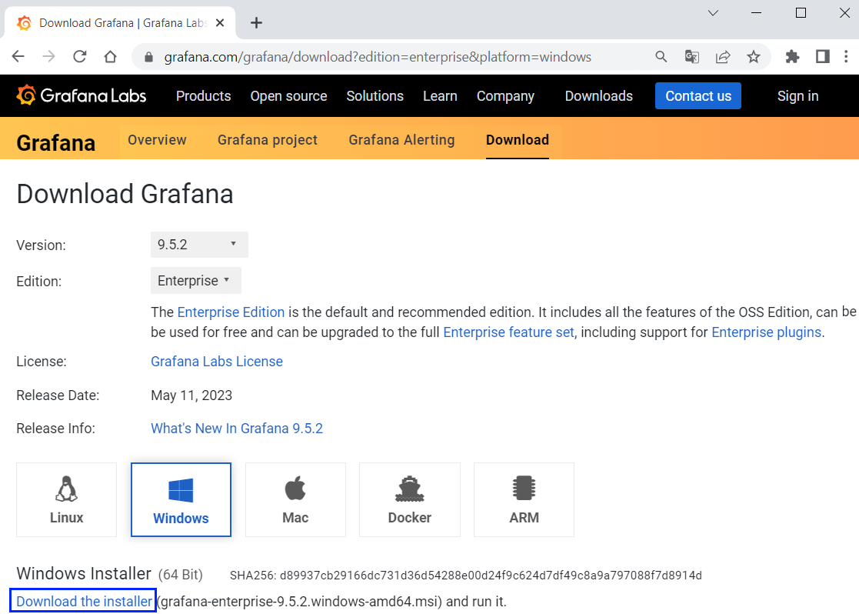
Choose latest version, "Enterprise" edition and your OS.
Click on the installer file
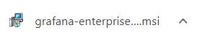
Follow the setup wizard to install Grafana